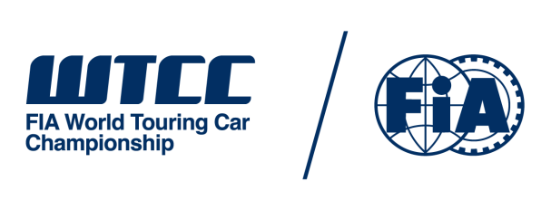 | NATIONAL MEDIA APPLICATION*  WTCC RACE OF RUSSIA 2016  EVENT MEDIA CREDENTIAL  USE ONE FORM PER PASS REQUESTED

THIS FORM IS FOR PRINTED PUBLICATIONS, AGENCIES AND WEBSITES BASED IN RUSSIA ONLY. INTERNATIONAL PRINTED PUBLICATIONS, AGENCIES AND WEBSITES MUST FOLLOW THIS LINK FOR GUIDANCE AND TO APPLY FOR ACCREDITATION: http://www.fia.com/media-center/media_accreditation/World%20Touring%20Car%20Championship

*ALL TV, RADIO, WEBSITES INTENDING TO STREAM WTCC-RELATED AUDIO AND/OR VISUAL CONTENT, AND WEBSITES AFFILIATED TO TV STATIONS (NATIONAL AND INTERNATIONAL) MUST EMAIL ANTONIOS@DISCOVERY.COM

TO BE RETURNED TO EUGENIA BAZAROVA, BAZAROVA@MOSCOWRACEWAY.COM BY 28 MAY 2016

A

PUBLICATION / AGENCY
COUNTRY
ADDRESS

CITY ZIP CODE
TELEPHONE + EMAIL
CHIEF/SPORTS EDITOR (please mark accordingly)
TELEPHONE + EMAIL
CIRCULATION…………………………………….READERSHIP…………………………………………

DAILY WEEKLY MONTHLY OTHER

B
PASS REQUESTED TO ATTEND THE EVENT AT MOSCOW RACEWAY

JOURNALIST PHOTOGRAPHER JO/PH TECHNICIAN

NAME OF REPRESENTATIVE……………………………………………………………………………...

TELEPHONE + EMAIL

C
I HAVE READ AND UNDERSTOOD THE FIA ACCREDITATION CRITERIA AND I ATTEST THAT:
- I HAVE ENCLOSED A FORMAL APPLICATION ON MY AGENCY/PUBLICATION’S OFFICIAL LETTERHEAD, SIGNED BY THE CHIEF EDITOR/SENIOR MEMBER OF EDITORIAL STAFF;
- I HAVE ENCLOSED A PHOTOCOPY OF MY NATIONAL PRESS CARD;
- OUR PUBLICATION IS ON SALE TO THE PUBLIC;
- OUR AGENCY FULFILLS THE CRITERIA OF CIRCULATION AND QUALITY REQUIRED BY THE FIA;

Signed ……………………………………………………. Date …………………………….

Title …………………………………………………….

LATE OR INCOMPLETE APPLICATIONS MAY NOT BE CONSIDERED.

APPLICATION MUST BE RECEIVED NO LATER THAN 28 MAY 2016

